|  |
| --- |
| ENUMOX Games inc. |
| COMP397 – Assignment 2 |
| **2D Scrolling Game** |
| Version #1.0  All work Copyright © 2020 by ENUMOX Games inc.  All rights reserved. |
| **Akhil Sanjeev** |
|  |



|  |
| --- |
| April 04-2020 |

**Table of Contents**

Table of Contents

Version History 3

Game Overview 4

Game Play Mechanics 4

Camera 4

Controls 4

Saving and Loading 4

Interface Sketch 4

Levels 6

Characters 7

Non-player Characters 7

Enemies 7

Scoring 7

Sound Index 7

Art / Multimedia Index 7

# Version History

Git HUB Link: <https://github.com/appuzzAk/Comp-397-2DScrollingGame_AkhilSanjeev.git>

C:\Users\Owner\Desktop\GitHUB\Comp-397-2DScrollingGame_AkhilSanjeev>git log

commit 8bc4d4c6b37fa6c3caeb6a9a5260de43c8ef0faf (HEAD -> master, origin/master)

Author: AKHIL SANJEEV <51760183+appuzzAk@users.noreply.github.com>

Date: Sat Apr 4 19:34:59 2020 -0400

2D Scrolling Game

commit 1481056f49b21462b513388ad1544443d51b5301

Author: AKHIL SANJEEV <51760183+appuzzAk@users.noreply.github.com>

Date: Sat Apr 4 19:31:33 2020 -0400

Initial commit

# Game Overview

This is a 2D- Scrolling game where the goal is to catch as many stars as possible while dodging all the minesweepers. The player loses a life if the boy hits the minesweeper. The player has a total of five lives per game. 100 points will be added to the score per star.

# Game Play Mechanics

The boy can move back and forth in the screen using the mouse. And can jump to catch the stars using space bar. The game ends when all the 5 lives are over and asks to restart, if the player wants to restart.

# Camera

*Side view*

# Controls

*Space bar and mouse*

# Saving and Loading

*No*

# Interface Sketch

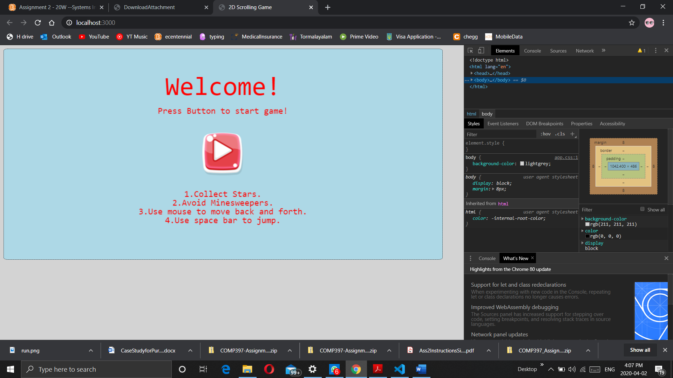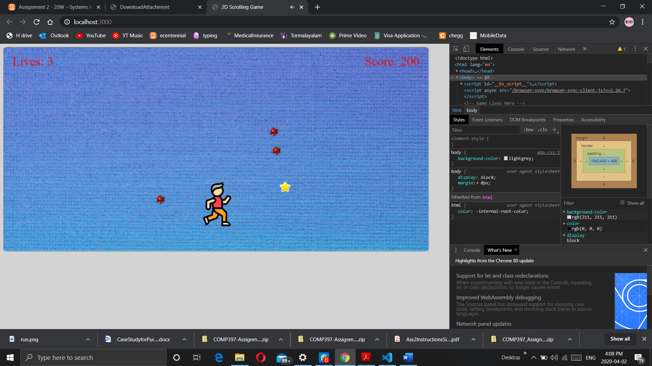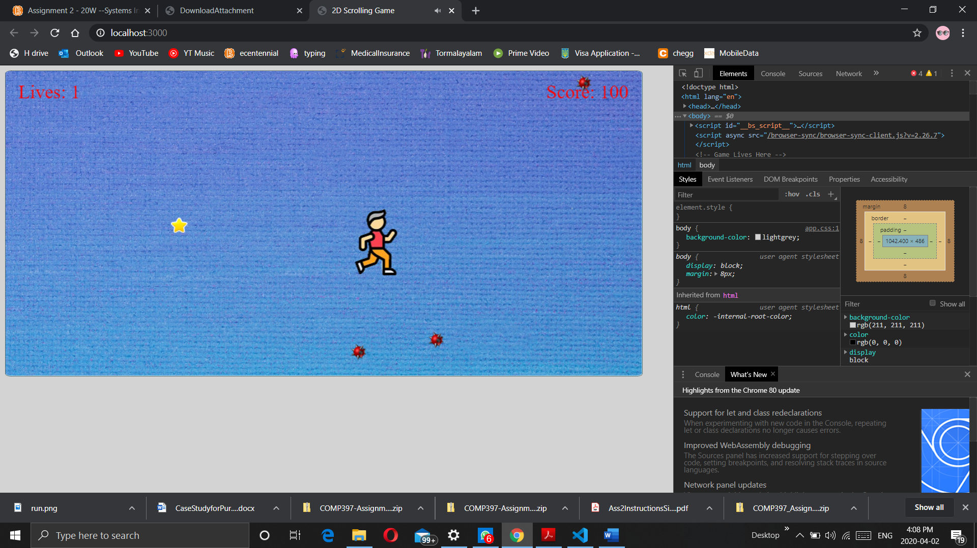

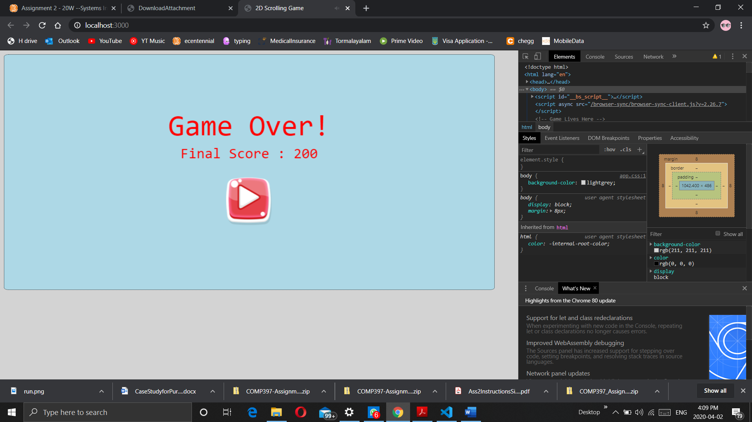

# Levels

*1*

# Characters

*Boy*

# Non-player Characters

*Star*

*Minesweepers*

# Enemies

*Minesweeprs*

# Scoring

100 points per star

1 life lost per minesweeper hit

# Sound Index

1. starHit : "/Assets/audio/life.wav"
2. bgMusic : "/Assets/audio/bg.mp3"
3. sweeperHit : "/Assets/audio/sweeperHit.wav"

# Art / Multimedia Index

1. *"StartButton" : "/Assets/images/StartButton.png"*
2. *"boy" : "/Assets/images/boy.png"*
3. *"bg" : "/Assets/images/BG.png"*
4. *"star" : "/Assets/images/star.png"*
5. *"sweeper" : "/Assets/images/minesweeper.png"*